Android Developer Bootcamp

Student Application Form

Workshop #01

🎯 Purpose
This workshop helps you practice designing a scrollable student application form using XML layouts in Android.
You will learn how to use ScrollView, LinearLayout, GridLayout, TextView, EditText, and Button components to create an attractive registration form.

🧩 Problem
Design a Student Application Form UI in Android using XML.

📚 Course Selection
Display a section title:
- Text: "Choose Course"
Below the title, create a GridLayout containing four buttons:
- Android
- Java
- Python
- Web Dev
Arrange the buttons in 2 columns.

How to Solve
Checkout the workshop from Git Repo:
git clone -b <user-branch> <repo-URL>
- Open the root folder inside Android Studio.
- Create the layout using XML only.
- Run the application on an emulator or Android device.

🎯 You Will Achieve

After completing this workshop, you will understand:
- How to use ScrollView in Android.
- How to design a form using LinearLayout.
- How to collect user information using EditText.
- How to organize buttons using GridLayout.
- How to create a simple student application interface.
- How to apply spacing, colors, and styling to improve UI design.

📸 Screenshots

Before Implementation

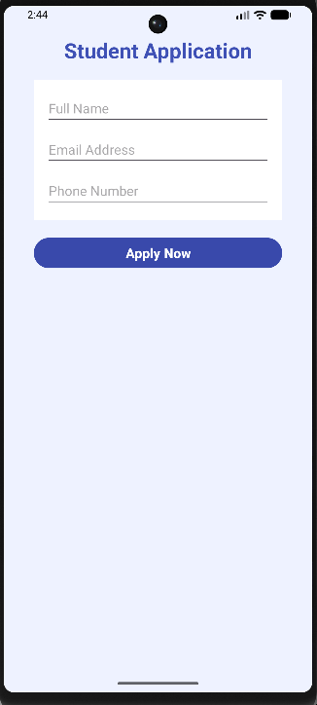

After Implementation
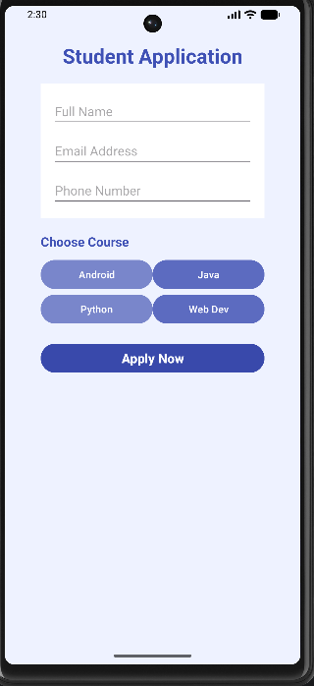

How to Submit Your Workshop
Push your project back to the same Git branch using:
git add .
git commit -m "Completed Student Application Form Workshop"
git push origin <user-branch>

🚀 Happy Coding! 🎨📱

